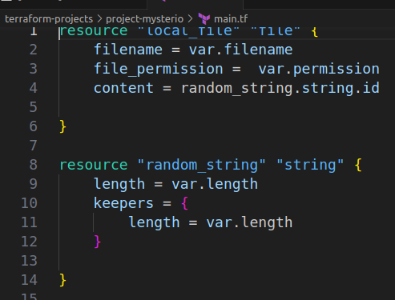
LAB 10: LifeCycle Rules

Q-1 We have a directory created called /root/terraform-projects/project-mysterio. The main.tf file already has a couple of resource blocks.
Which resource types do they use?
A-1 file & string

Q-2 Now, create these two resources that have been defined in this configuration file.
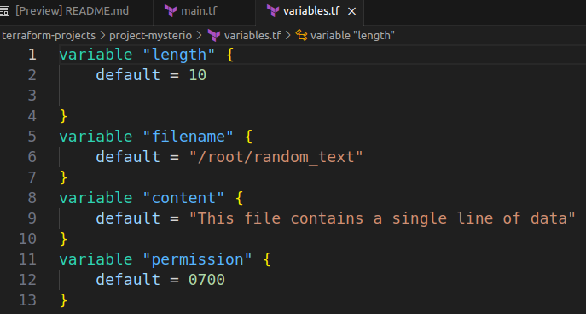
A-2 Done

Q-3 Which resource is created first in this case ?
A-3 String. Bcz, There is an implicit dependency defined between the resources.
terraform show

terraform show
# local_file.file:
resource "local_file" "file" {
content = "m_XU%x${0N"
content_base64sha256 = "0ZX7pJJ/RQMrkNWrbsvS9hG+1XguxVQUjwElZF1ez3c="
content_base64sha512 = "FQtHHrX562UfAof9im7XQICOyvUNoYifPYp2cmr/CwzlaT5J5wklRKPhrXNoMsM+pVCI71WZUflDtFTmVpTUJg=="
content_md5 = "f0b4aca5d4228602e3dbfdd38696bade"
content_sha1 = "e442bac50d9a10ae2d5d8c540df4fa9a1a4da20e"
content_sha256 = "d195fba4927f45032b90d5ab6ecbd2f611bed5782ec554148f0125645d5ecf77"
content_sha512 = "150b471eb5f9eb651f0287fd8a6ed740808ecaf50da1889f3d8a76726aff0b0ce5693e49e7092544a3e1ad736832c33ea55088ef559951f943b454e65694d426"
directory_permission = "0777"
file_permission = "700"
filename = "/root/random_text"
id = "e442bac50d9a10ae2d5d8c540df4fa9a1a4da20e"
}

# random_string.string:
resource "random_string" "string" {
id = "m_XU%x${0N"
keepers = {
"length" = "10"
}
length = 10
lower = true
min_lower = 0
min_numeric = 0
min_special = 0
min_upper = 0
number = true
numeric = true
result = "m_XU%x${0N"
special = true
upper = true
}
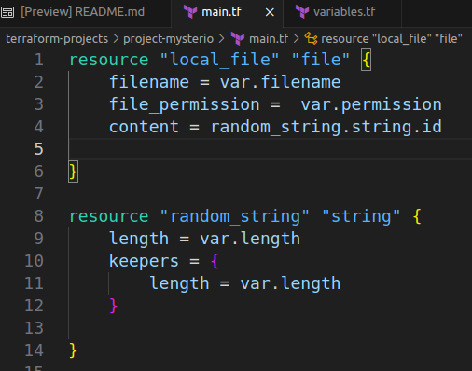
Q-4 We have modified the resource configuration again. Run a terraform plan now. What would happen?

A-4 Both file and random string will replace.
Bcz, file permissions 700 to 770 and varialble “length” 10 to 12 will changed/replaced.

terraform plan
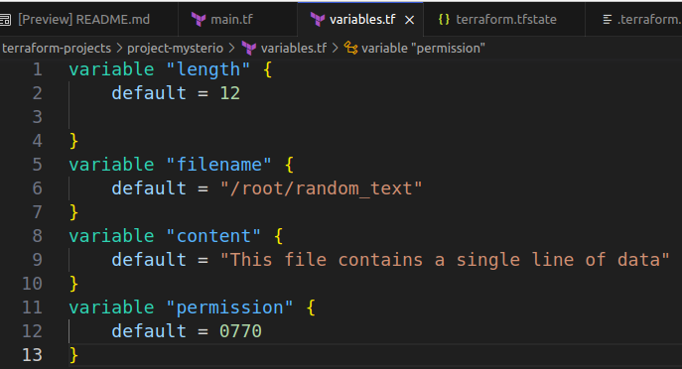
random_string.string: Refreshing state... [id=m_XU%x${0N]
local_file.file: Refreshing state... [id=e442bac50d9a10ae2d5d8c540df4fa9a1a4da20e]

Terraform used the selected providers to generate the
following execution plan. Resource actions are
indicated with the following symbols:
-/+ destroy and then create replacement

Terraform will perform the following actions:

# local_file.file must be replaced
-/+ resource "local_file" "file" {
~ content = "m_XU%x${0N" # forces replacement -> (known after apply) # forces replacement
~ content_base64sha256 = "0ZX7pJJ/RQMrkNWrbsvS9hG+1XguxVQUjwElZF1ez3c=" -> (known after apply)
~ content_base64sha512 = "FQtHHrX562UfAof9im7XQICOyvUNoYifPYp2cmr/CwzlaT5J5wklRKPhrXNoMsM+pVCI71WZUflDtFTmVpTUJg==" -> (known after apply)
~ content_md5 = "f0b4aca5d4228602e3dbfdd38696bade" -> (known after apply)
~ content_sha1 = "e442bac50d9a10ae2d5d8c540df4fa9a1a4da20e" -> (known after apply)
~ content_sha256 = "d195fba4927f45032b90d5ab6ecbd2f611bed5782ec554148f0125645d5ecf77" -> (known after apply)
~ content_sha512 = "150b471eb5f9eb651f0287fd8a6ed740808ecaf50da1889f3d8a76726aff0b0ce5693e49e7092544a3e1ad736832c33ea55088ef559951f943b454e65694d426" -> (known after apply)
~ file_permission = "700" -> "770" # forces replacement
~ id = "e442bac50d9a10ae2d5d8c540df4fa9a1a4da20e" -> (known after apply)
# (2 unchanged attributes hidden)
}

# random_string.string must be replaced
-/+ resource "random_string" "string" {
~ id = "m_XU%x${0N" -> (known after apply)
~ keepers = { # forces replacement
~ "length" = "10" -> "12"
}
~ length = 10 -> 12 # forces replacement
~ result = "m_XU%x${0N" -> (known after apply)
# (9 unchanged attributes hidden)
}

Plan: 2 to add, 0 to change, 2 to destroy.

Q-5 why is the string resource being re-created ?
A-5 see forced replacement
The vallue for the argument called keepers has changed

Q-6 All the resources for the random provider can be recreated by using a map type argument called keepers. A change in the value will force the resource to be recreated.
This argument accepts arbitrary key/value pairs and in our example, it is set to the key called length whose value was updated from 10 to 12 in the variables.tf file.
Running a terraform apply now will destroy the current random_string resource and then create a new one with the length that is 12 characters long.
A-6 Done
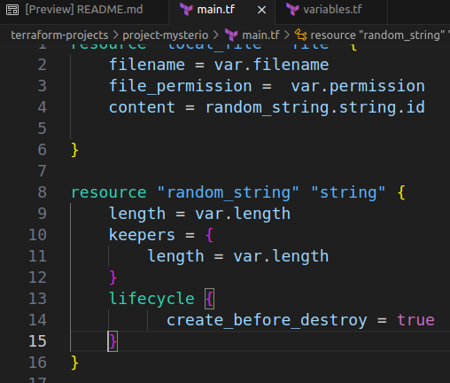
Q-7 Let's change the order in which the resource called string is recreated. Update the configuration so that when applied, a new random string is created first before the old one is destroyed.
When ready, apply the changes with terraform apply
A-7 Add lifecycle rule in the random_string resource block.
Lifecycle {
creare_before_destroy = true
}

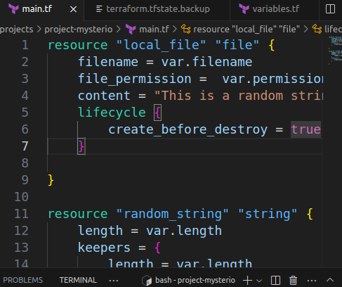
Q-8 The resource block for the file resource has been updated! This will force the resource to be recreated during the next apply! But, before that, let's also add a lifecycle rule of create_before_destroy to this resource block.
When ready, apply the changes with terraform apply
Important: Once the lifecycle rule has been added, only run the apply command once. We will learn why soon.
A-8 lifecycle {
create_before_destroy = true
}
Add this rule into file resource.

Q-9

